**Project Design Phase-I Solution Architecture**

|  |  |
| --- | --- |
| Date | 24 November 2023 |
| Team ID | NM2023TMID11936 |
| Project Name | Climate TrackSmart using blockchain |
| Maximum Marks | 4 Marks |

**Solution Architecture:**

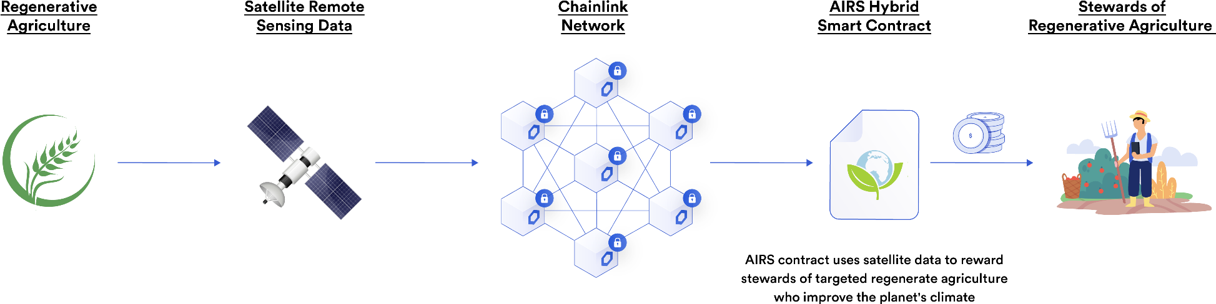

# Components:

1. Blockchain Infrastructure:
   1. Choose a suitable blockchain platform (e.g., Ethereum, Hyperledger Fabric) based on scalability, consensus mechanism, and smart contract capabilities.
   2. Develop smart contracts: Define the rules for tracking climate actions, rewards, and verification mechanisms.
2. Climate Action Tracking Interface:
   1. User Interface (UI) or Application Programming Interface (API) for users to input and track climate actions. This can include activities like reducing carbon emissions, adopting renewable energy, or sustainable practices.
   2. Integration with IoT devices or external data sources for real-time data collection (e.g., sensors measuring energy consumption).
3. Data Verification Layer:
   1. Oracles or external data sources to verify the accuracy and legitimacy of climate actions recorded on the blockchain. This ensures that the data inputted is reliable and trustworthy.
4. Tokenization and Incentive Mechanism:
   1. Creation of utility tokens (or using an existing cryptocurrency) to incentivize and reward users for their climate-positive actions.
   2. Smart contracts governing token distribution based on validated climate actions.
5. Analytics and Reporting:
   1. Tools and algorithms for analyzing data stored on the blockchain to generate reports and insights.
   2. Visualization dashboards for users and stakeholders to track overall progress, individual contributions, and impact.

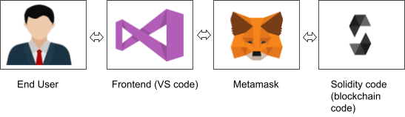

# Workflow:

1. User Engagement:
   1. Users register and perform climate-positive actions through the platform.
   2. Actions are recorded on the blockchain via smart contracts.
2. Verification:
   1. Data undergoes verification using oracles, IoT devices, or trusted sources to ensure authenticity.
3. Token Rewards:
   1. Verified actions trigger token rewards based on predefined criteria within the smart contracts.
4. Analytics and Reporting:
   1. Blockchain-stored data is analyzed to generate reports on the impact of collective actions.
   2. Insights are shared with users and stakeholders.

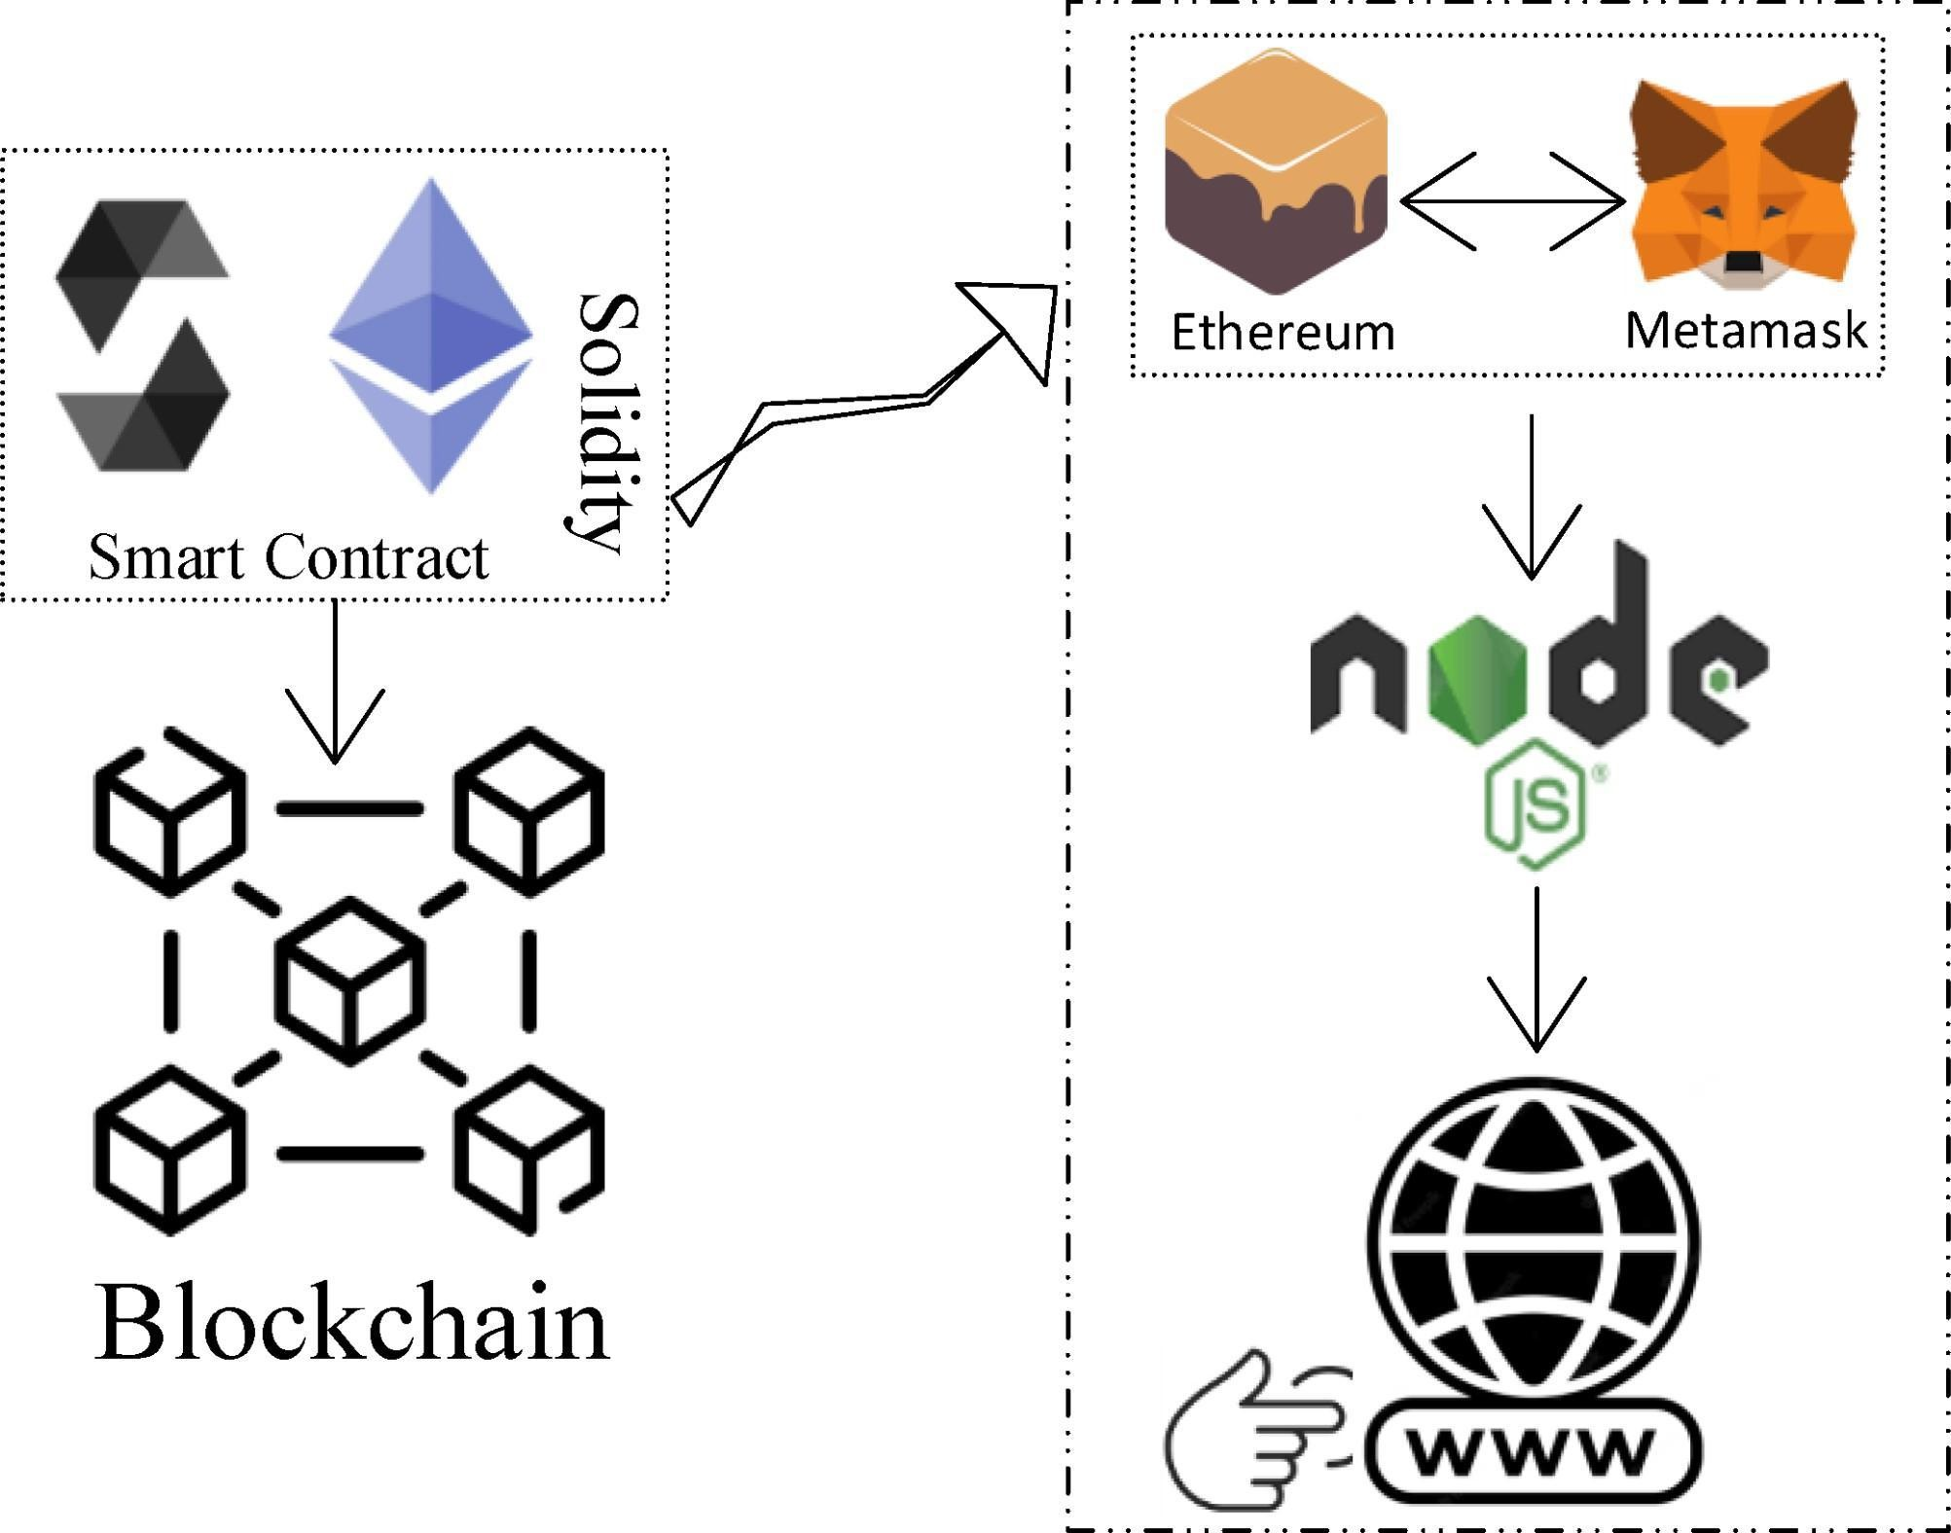

**Considerations:**

* **Scalability:** Ensure the chosen blockchain platform can handle a high volume of transactions.
* **Privacy:** Implement privacy measures to protect sensitive user data while ensuring transparency.
* **Regulatory Compliance:** Adhere to local and international regulations concerning cryptocurrencies and environmental incentives.
* **User Experience:** Design an intuitive interface to encourage user engagement and simplify action tracking.
* **Sustainability:** Consider the environmental impact of the chosen blockchain network's consensus mechanism.